**Design and Development of Beam Status Identification System**

## 220px-Raja_Ramanna_Centre_for_Advanced_Technology.svg

## A Project Report submitted at

Raja Ramanna Centre for Advanced Technology, Indore

In partial fulfillment of the Degree

Of

Bachelor of Technology

In

Computer Science Engineering

**Submitted by**

Brijgopal Bharadwaj

**Guided by**

Mr. Surendra Yadav

Mr. Avanish Ojha

Mr. T.A. Puntambekar

**Beam Diagnostics Section**

**Raja Ramanna Centre for Advanced Technology, Indore**

May-Jun 2019

Declaration

I hereby declare that the thesis entitled **“Design and Development of Beam Status Identification System”** submitted for the degree of Bachelor of Technology in Computer Science Engineering from Vellore Institute of Technology (VIT), Vellore, Tamil-Nadu is the original work carried out by me at Raja Ramanna Centre for Advanced Technology, Indore under the supervision of **Mr. Surendra Yadav**, Scientiﬁc Oﬃcer ‘F’, Beam Diagnostic Section, RRCAT, Indore. The matter embodied in this report has not been previously formed the basis of any Degree or Diploma or other similar title or recognition.

**Brijgopal Bharadwaj**

( B.Tech. CSE )

This is to certify that above statement made by the student is correct to the best of our knowledge and belief.

**Mr Surendra Yadav** Scientist Officer ‘F’ Beam Diagnostic Section RRCAT, Indore (MP).

****

**Government of India**

**Department of Atomic Energy**

**RAJA RAMANNA CENTRE FOR ADVANCED TECHNOLOGY**

**Indore-452 013, INDIA**



**\_\_\_\_\_\_\_\_\_\_\_\_\_\_\_\_\_\_\_\_\_\_\_\_\_\_\_\_\_\_\_\_\_\_\_\_\_\_\_\_\_\_\_\_\_\_\_\_\_\_\_\_\_\_\_\_\_\_\_\_\_**

**CERTIFICATE**

This is to certify that the dissertation work entitled, “**Design and Development of Beam Status Identification System**” submitted by **Mr. Brijgopal Bharadwaj**, student of Computer Science Engineering, from Vellore Institute of Technology (VIT), Vellore, Tamil-Nadu, is hereby approved as a credible work carried out by him during the period from 14th May 2018 to 28th June 2018 at Beam Diagnostics Section (BDS), RRCAT , Indore under our supervision and is recommended towards partial fulfilment for degree of Bachelor of Engineering.

**Mr. C. P. Navathe Mr. T. A. Puntambekar**

**Head, ACBDD Head, Beam Diagnostic Section**

**RRCAT, Indore. RRCAT, Indore.**

**Mr. Surendra Yadav**

**Scientific Officer ‘F’**

**BDS, RRCAT, Indore.**

Acknowledgement

The project work done required a great deal of guidance and assistance and I appreciate the support that I received while working in this section. The project gave me an opportunity to work under Mr. Surendra Yadav, Scientific Officer (SO/F) in the Beam Diagnostic Section at RRCAT, Indore. I am greatly obliged to him for his guidance, invaluable and generous suggestions throughout the project. I am thankful to RRCAT for giving me an opportunity to work on this project and to my college for granting me permission to join this institute.

I am also highly indebted to Mr. T.A. Puntambekar (OS, Head-Beam Diagnostics & Coolant Systems Division) and Mr. Yogendra Sheth (Head, BDS) for giving me this opportunity to carry my project work under BDS, RRCAT.

I also express my sincere thanks to Mr. Avanish Ojha, who helped me by providing advice and discussing problems on various occasions.

Abstract

Synchrotron radiation (SR) is a type of electromagnetic radiation generated by bending the path of electron bunches moving at speed close to that of light. It has emerged as a powerful tool for research in several areas such as material science, chemistry, biology, medicine and semiconductor technology.

The Indus Accelerator complex at Raja Ramanna Centre of Advanced Technology (RRCAT), Indore consists of two synchrotron radiation sources, Indus-1 (450 MeV electron storage ring) and Indus-2 (2.5 GeV electron storage ring).

The parameters of the electron beam circulating in the storage ring of synchrotron radiation sources can be analysed by using diagnostic devices. Several Beam Position Indicators (BPIs) are installed in the Indus-2 for measurement of the position of electron beam, in reference to its cross-section. This data is collected, filtered, and suitably segmented, to be processed by the classifier.

The classified data thus obtained is used for further identification of the following beam-parameters, and the obtained results are displayed to the user, using the developed GUI:

* Beam Energy
* Zone of operation
* SOFB Feedback status

Table of Contents

Chapter 1

Introduction

**1.1 Indus Accelerator Complex:**

**Raja Ramanna Centre for Advanced Technology (RRCAT)** is an undertaking of **Department of Atomic Energy (DAE)**, Government of India, engaged in R & D in non-nuclear research fields of Lasers, Particle Accelerators & related technologies. On February 19, 1984 the President of India, Gyani Zail Singh, laid the foundation stone of the centre. Construction of laboratories and houses began in May 1984. One of the major projects in operation at RRCAT, Indore, are the two particle accelerators, that are capable of producing the synchrotron radiations: **Indus-1** & **Indus-2**.

Indus-1 is the first Indian synchrotron radiation source which was commissioned in early 1999. It is a 450 MeV electron storage ring which provides a broad electromagnetic spectrum extending from far infrared to soft x-ray region. It has opened up a possibility to carry out research activity using the soft x-ray to ultraviolet radiation (10 Å < λ < 1000 Å) in India.

Indus-2 is a 2.5 GeV electron storage ring designed for the production of x-rays. The synchrotron radiation emitted from its bending magnets has broad spectrum covering soft and hard x-ray regions with a critical wavelength of ~2 Å. With its circumference of 172.5 m, and beam energy of 2.5 GeV, Indus-2 is presently the largest and the highest energy particle accelerator in the country.

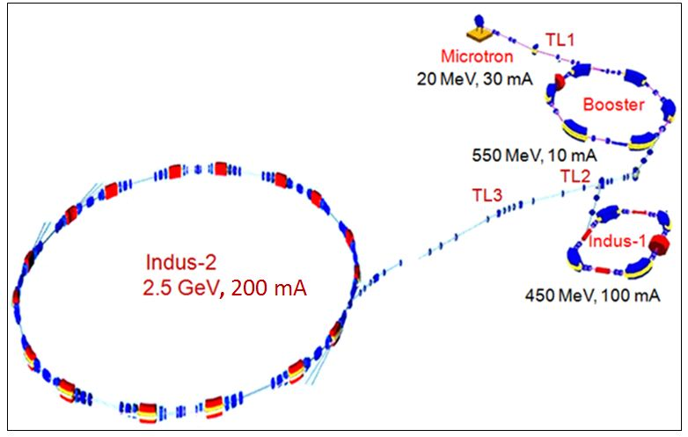

*Figure - Schematic of RRCAT Indus Accelerator complex*

The electrons are created and accelarated to 20 MeV in the microtron and infused through an transfer line TL-1 into the booster synchrotron where its energy is enhanced to 450 MeV / 550 MeV, based upon the target ring.

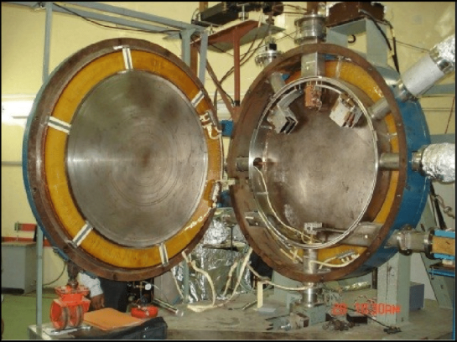 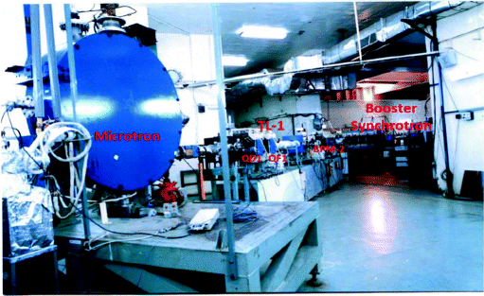

*Figure - Inside view of Microtron Figure - Microtron assembly, along with TL-1*

If the electron-beam is to be stored in Indus-1, the energy is increased to 450 MeV, and once this is achieved, the beam is sent to the Indus-1 ring via the transport line TL-2. If the beam is to be sent to the Indus-2 ring, it’s energy is increased to 550MeV, and then it is transferred to Indus-2 via the transport-line TL-3.

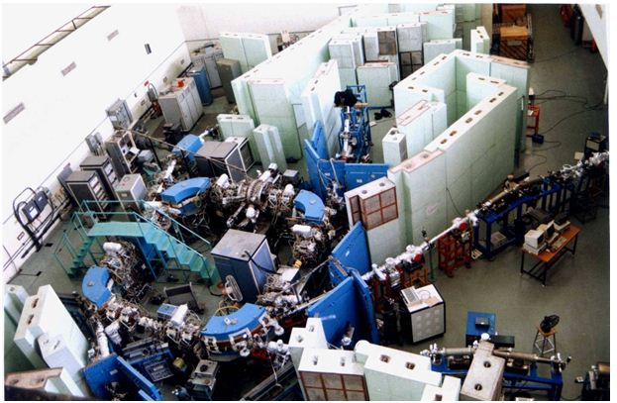

*Figure - Indus-1 Assembly*

Once the beam enters the Indus-2 storage ring, it is kept constant at 550MeV, until the required no. of electrons are accumulated. After that, the further supply of electrons is stopped, and this marks the end of the Injection-phase of the operational cycle. Then, the beam-energy is ramped up from 550MeV to 2.5GeV, in the ramping phase. Once this energy level is reached, further supply of energy is inhibited, and the beam enters the storage phase of the operational cycle, where the synchrotron radiation it produces near the bends, is ready to be used by the users to carry out the various types of research work.

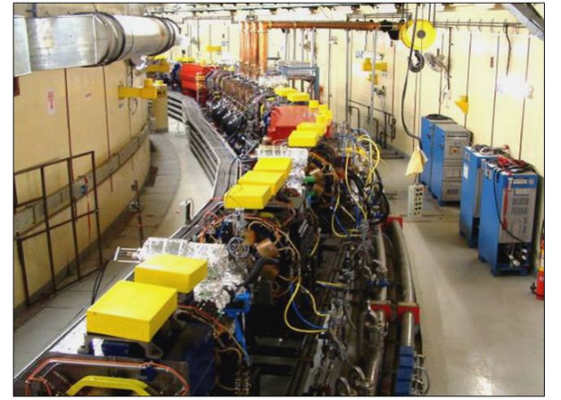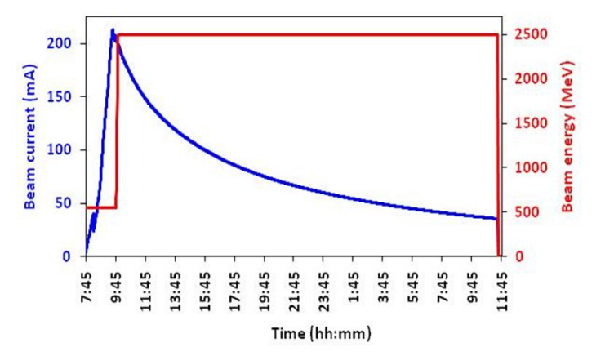

*Figure - Section of Indus-2 ring Figure - Indus-2 Beam accumulation & storage*

**1.2 Beam Position Indicator:**

Beam position indicator (BPI) is used to measure the position of the charge centroid of the electron beam circulating in the accelerator vacuum chamber. The measurement of electron beam position is done at 56 locations (40 individual type BPIs + 16 BPIs integrated to dipole vacuum chambers) using four-button electrodes type BPIs. Out of these 56 BPIs, 7 BPIs are in each cell. Since it is a non-interceptive type device, it can measure the beam position without disturbing it.Using these beam position indicators, the position of the equilibrium beam orbit and closed orbit distortion (COD) are obtained. This data is used by the control system to correct the COD.

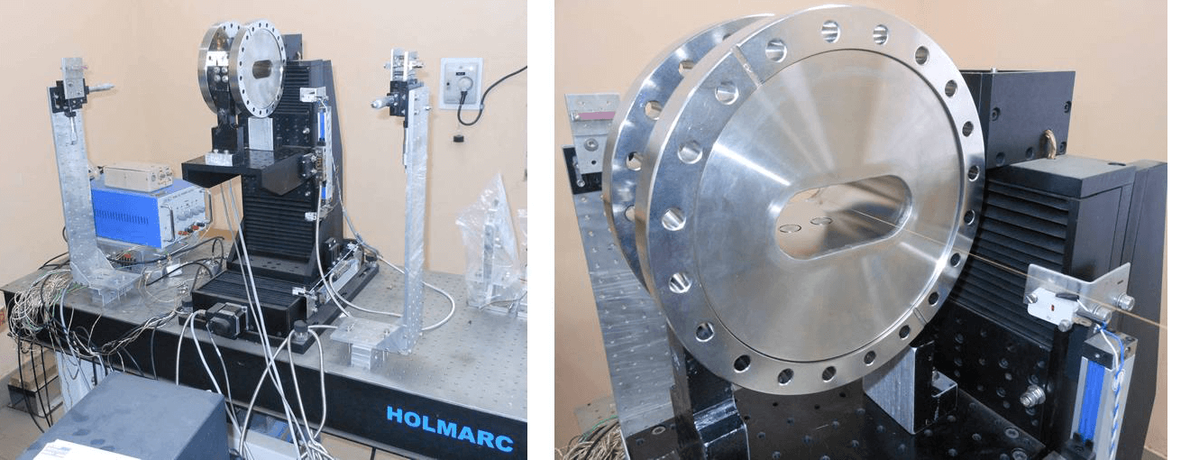

The device consists of four button shaped electrodes mounted symmetrically in the cross section of the accelerator vacuum chamber. The electron beam has an electromagnetic field associated with it. When the electron beam passes through the BPI, beam electric field induces charge on the electrode. The signal induced can either be voltage or current source. The signal induced on an electrode depends on the proximity of the beam to that electrode. The beam position with reference to the geometric center of the device can be obtained by detecting the four electrode signals and applying a suitable position algorithm.

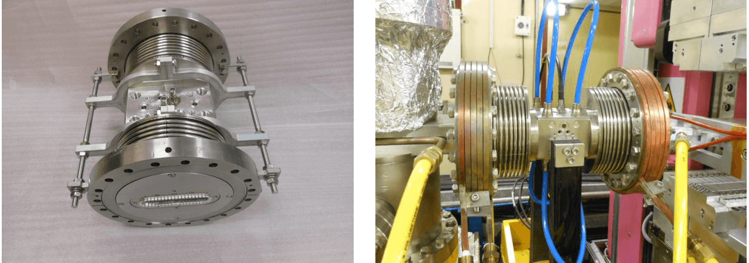

**1.3 Slow Orbit Feedback (SOFB) System:**

To provide stable photon beam for user experiments in Indus-2, orbit feedback correction schemes viz. Slow Orbit Feed Back (SOFB) and Fast Orbit Feed Back (FOFB) are provided in Indus-2 machine. These schemes restrict the perturbations occurring in the electron beam due to various noise sources to the acceptable levels.

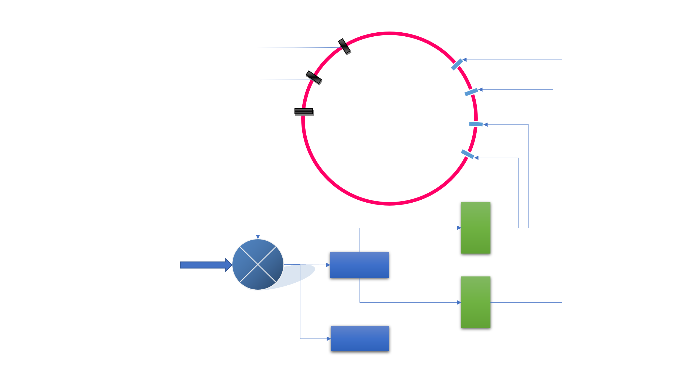

Chapter 2

Literature Survey

* 1. **K-means clustering:**

K-means clustering is a simple and widely-used unsupervised machine-learning algorithm.[1][5] It is a method to split a given data-set into smaller groups, traditionally called “clusters”, that contain similar items, with respect to the major attributes. [2] The “K” in the name signifies the no. of clusters we aim to segregate out of the given data-set.

This is an iterative method, that tries to treat the data-set as a collection of various points in a multi-dimensional hyper-space.[6] The algorithm tries to identify the ‘centroids’ for the various clusters, representing the central tendency of their respective data. These centroids are computed by the following expression:

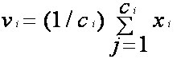

Where, ‘**vi**’ represents the mean-value for each data-attribute of the input data-set, ‘**ci**’.

The collection of all these ‘**vi**’ values represents the centroid for the given cluster.[4][5]

Geometrically, this represents the arithmetic mean of all the assigned data-points, for each co-ordinate axis, to the cluster of the centroid in question. The most widely accepted algorithm for this process is as follows:[11]

* From the given data-set, randomly select “K” no. of data-points to be the cluster-centroids, for the initial step of the procedure.
* For each data-point, compute the distance from all the identified centroids, using the Euclidean distance function: [8]

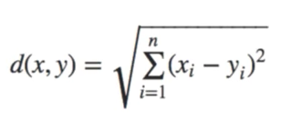

Where **xi** & **yi** represent the corresponding attributes of the data-point and the centroid in question, and d(x,y) is the distance between them.

* Identify the closest cluster, i.e. the cluster with the minimum euclidean distance.
* Select the cluster of this centroid as the new cluster for the data-point in consideration.
* Repeat the process again, if the distance between the previous set of clusters and the newly computed clusters is less than the pre-determined significance level.

The clusters thus assigned to the data-points are the ones that contain all the similar data, thus fulfilling our needs.[10]

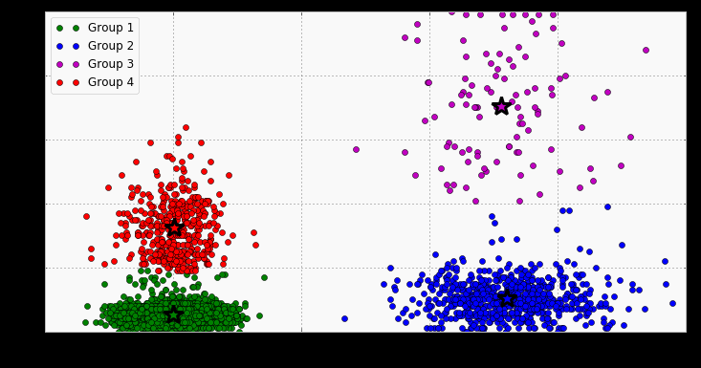

The value of the variable “K” is determined by plotting a figure similar to the one given below.[12] This graph is plotted between the average within-cluster distance, and the no. of clusters. As the no. of clusters increases, the average distance is bound to decrease. But, as evident from the figure, there comes a point beyond which the decrease is quite negligible.[6]

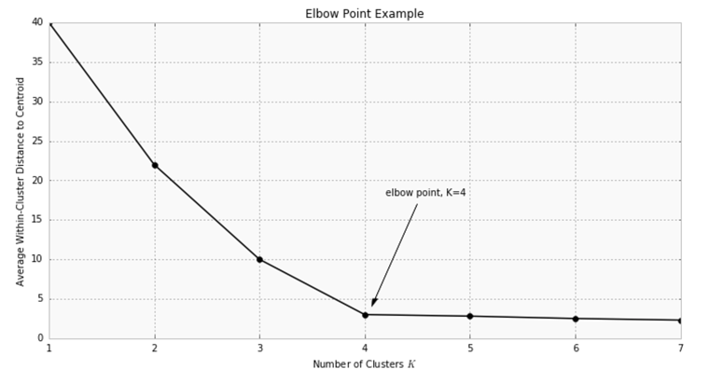

The K-means clustering is used to identify classes among the data, which have not been labelled in the data.[7] This can be used to design predictive models, that can treat the assigned clusters as the output of a classifier, and based on that train themselves to determine the class of the input test data.

**Advantages:[5]**

* The algorithm is fast.
* It is easily understandable.
* It is easily implementable.

**Disadvantages:[5]**

* The no. of clusters is required to be pre-defined.
* If the clusters are too close, the algorithm might be unable to distinguish them.
* The results are dependent on the mode of representation, i.e. they may vary according the mode of representation.
* The Euclidean distance calculation may unequally regard the weight of underlying factors. Thus, normalization is necessary.
* It can’t be used for categorical data.

Since the data we have dealt with in this project is the BPI data, which is numerical in nature, varies in a case-wise similar range, and is significantly distinguishable, the use of K-means clustering is justified here.

* 1. **MATLAB GUI:**

GUIs, or the Graphical User Interfaces, are an effective and easy-to-use method of enabling the user-interaction with the software-applications, thus eliminating the need to have a programming experience, or manually providing code-instructions, in order to make use of the application in consideration. This allows a wider user-reaching capability for the software, at the same time enhancing the user experience via specialized, intuitive, and visually-appealing feedback/response & error-handling procedures.

In order to apply such concepts to the programs written in MATLAB, it offers a special GUI-designing tool, called GUIDE, that is easy to operate and integrate with the existing software.[15] An application when opened using GUIDE, is editable via a special GUI-editing window that looks similar to the following figure:

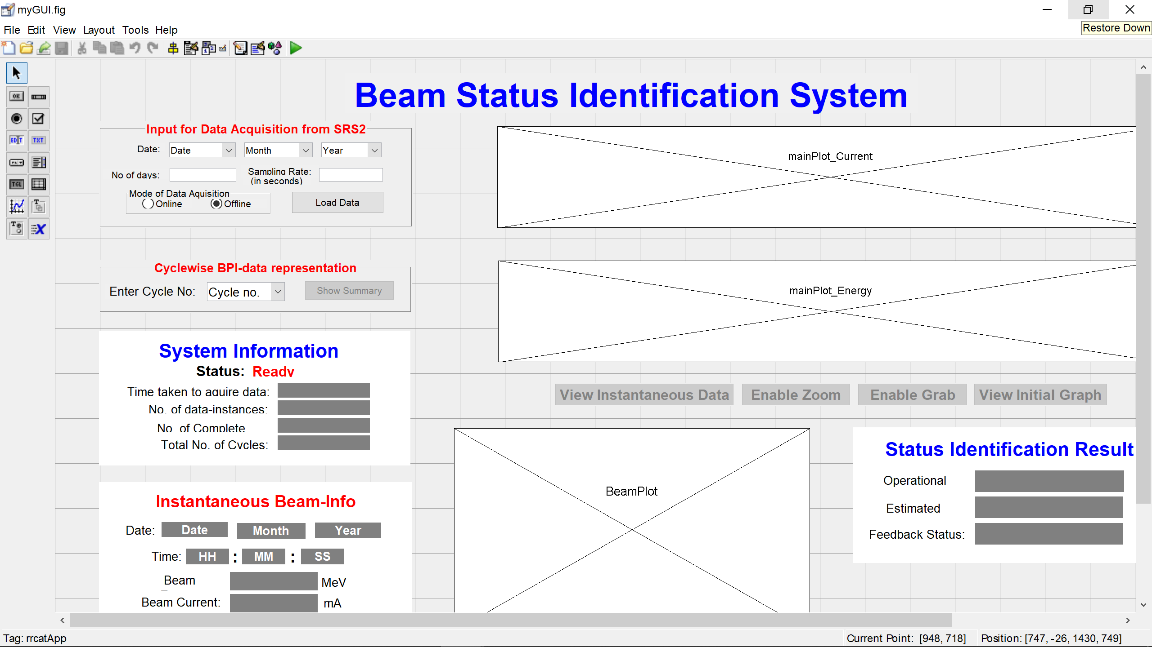

*Figure – A GUIDE view of the implemented GUI*

For each GUI, there are two corresponding files generated:

* Figure.fig
* Figure.m

The ‘Figure.fig’ is a collection of all the display-attributes of the front-end of the GUI. It deals with the properties of the GUIs, that pertain to the visual aspects, such as the font-size, dimensions of the various components of the GUI, Colour-scheme, etc. It is edited via the GUIDE editor window.[16]

The ‘Figure.m’ is the file which the contains all the user-defined logic that governs the operation and functioning of the GUI of the software-application. It is responsible for all the dynamic aspects of the GUI, such as the actions to be preformed on a button-press, or selection from a drop-down. It is constructed as a group of functions that are called on particular, pre-defined GUI-state changes. [15][16]

Chapter 3

Methodology

**3.1 Functional Block-Diagrams:**

***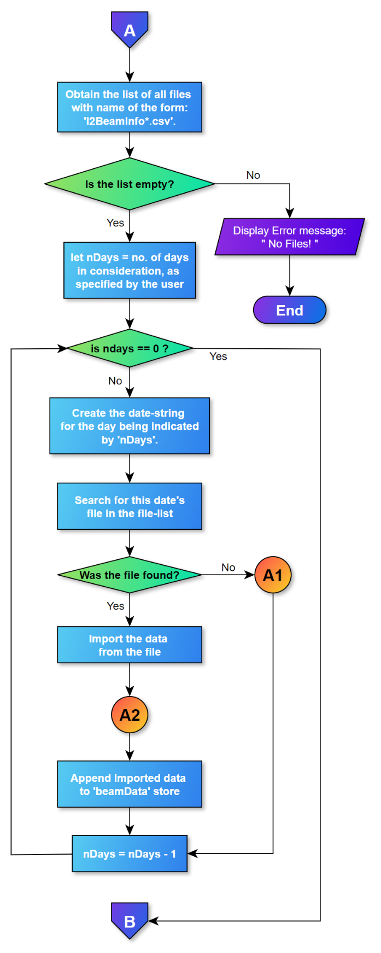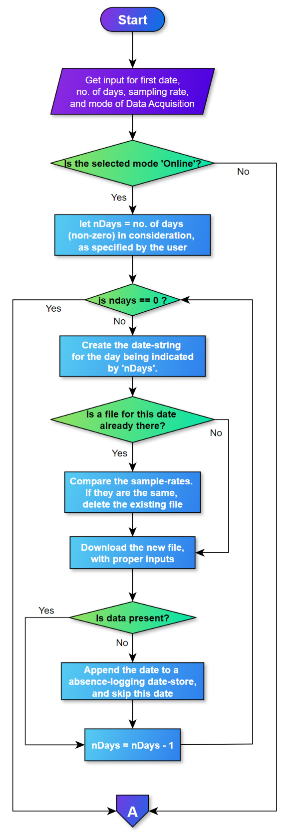Operational-cycles Identification***

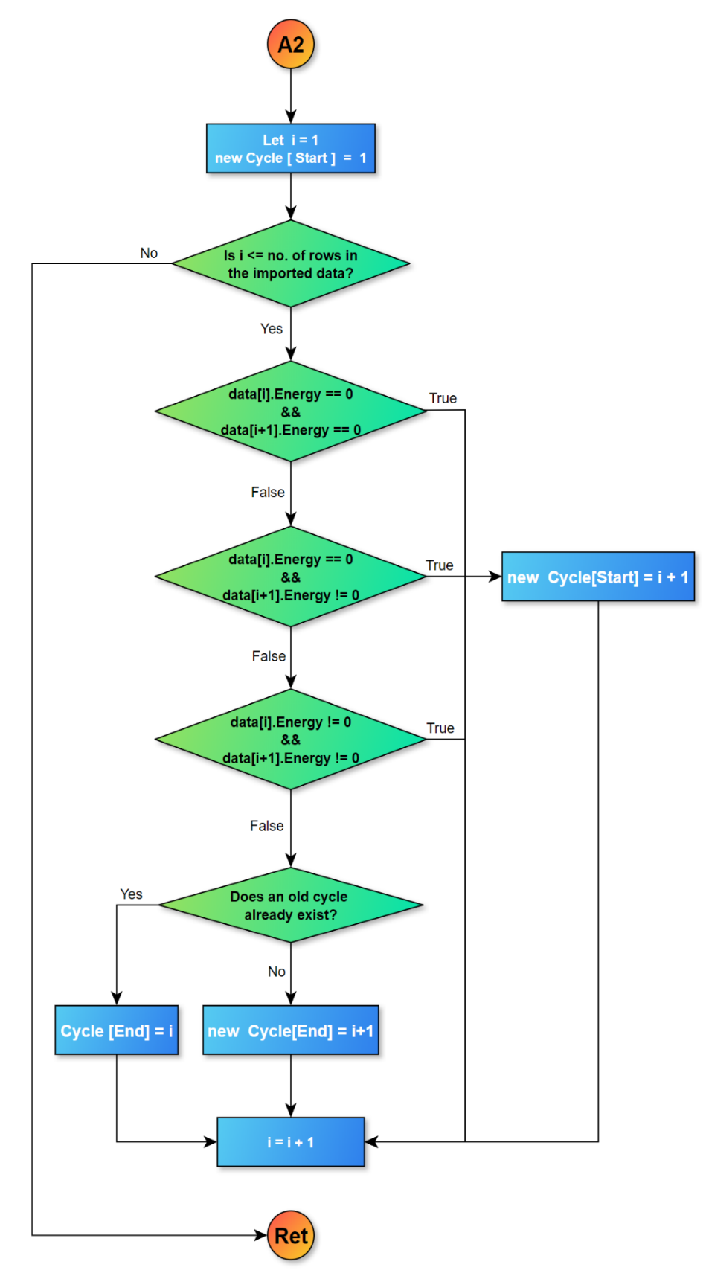

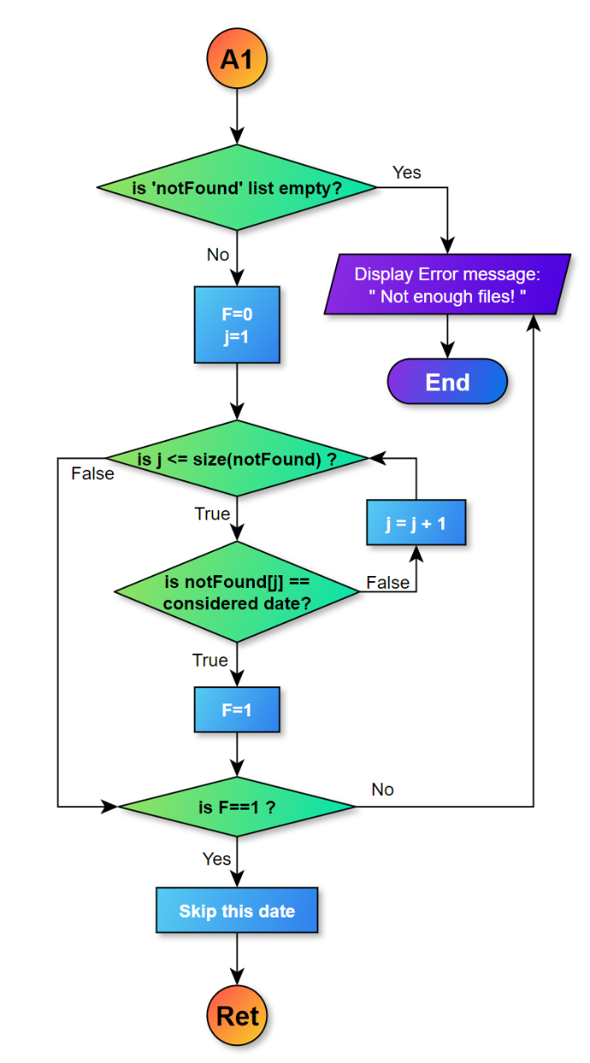

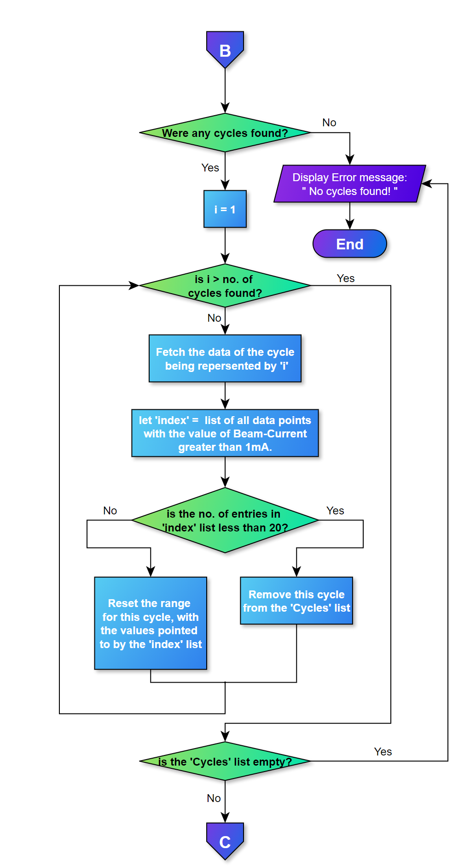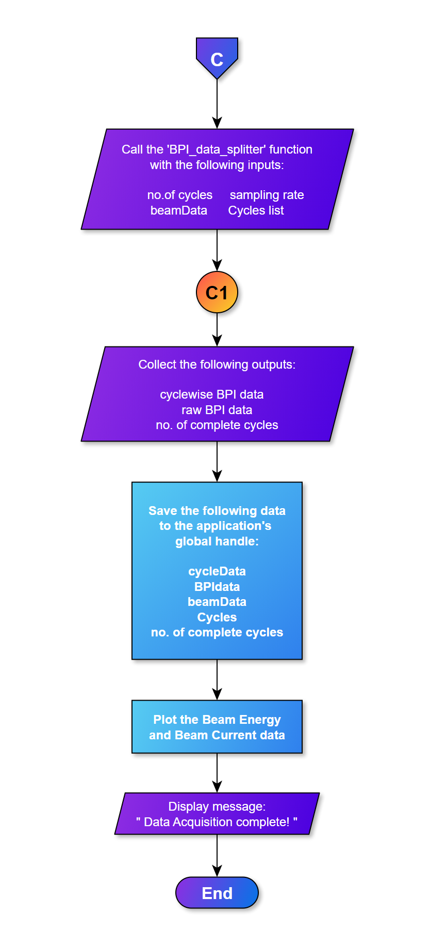

***BPI-data segmentation***

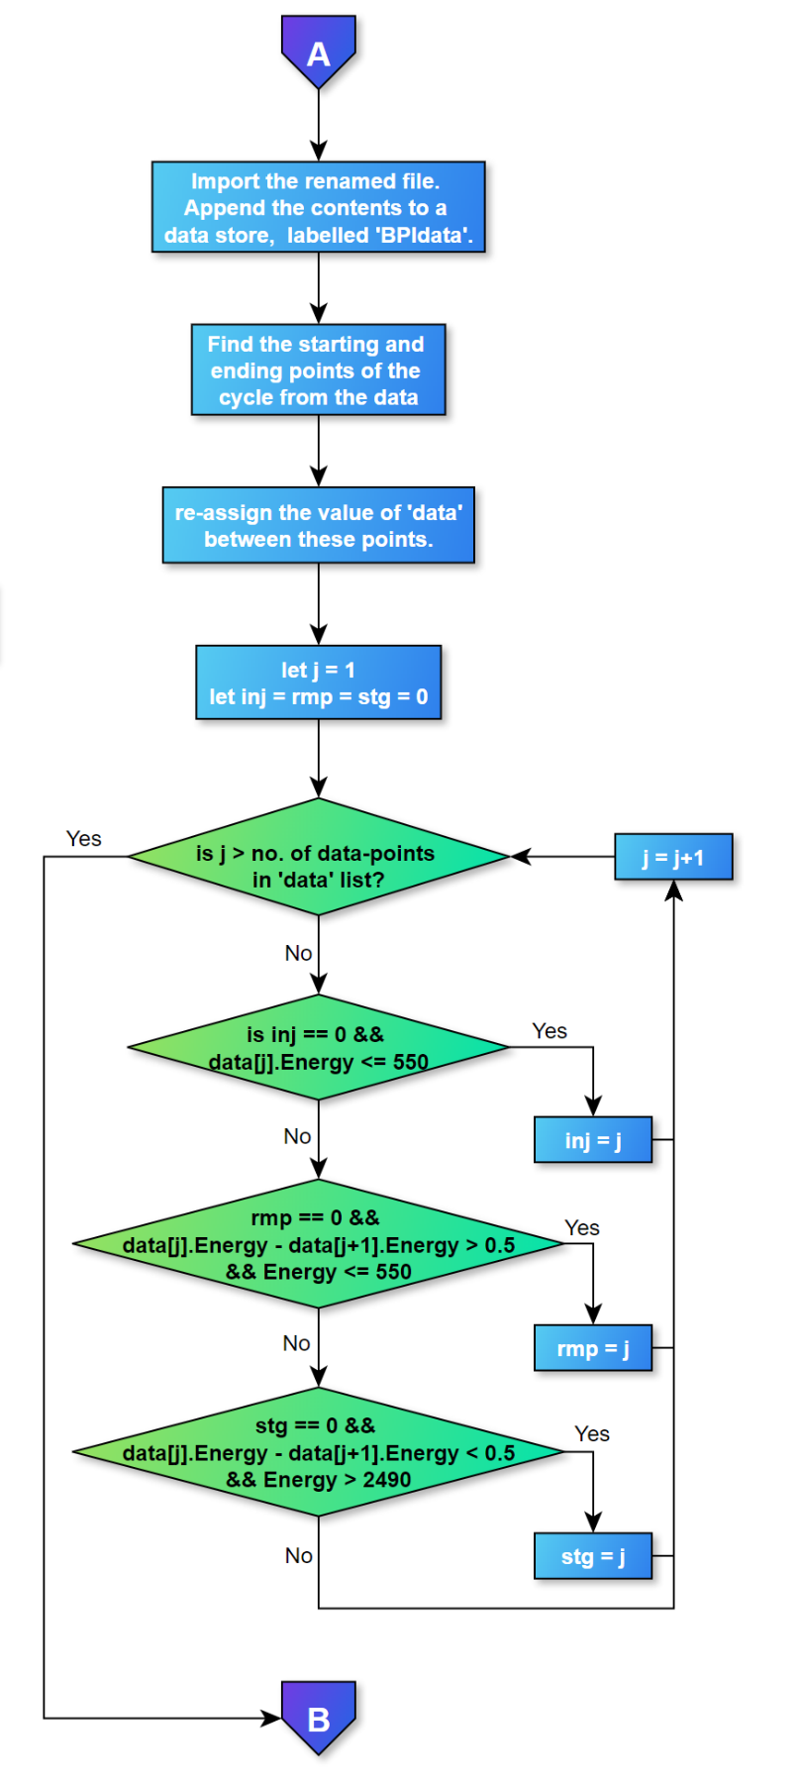

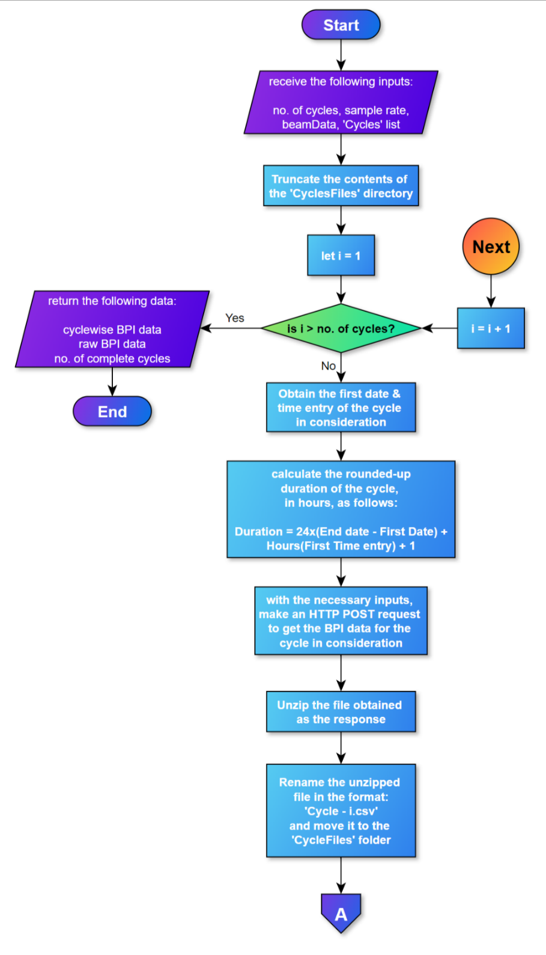

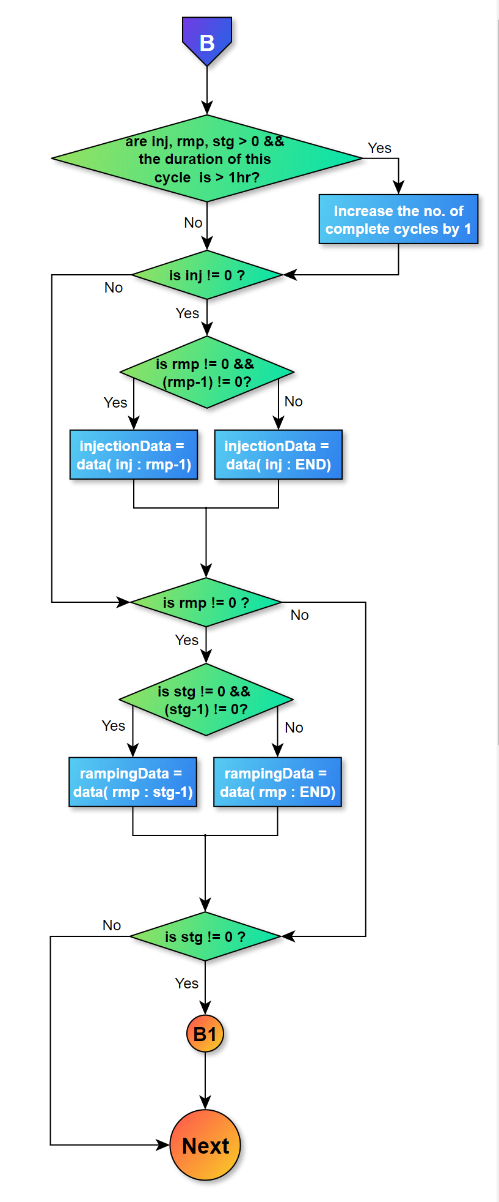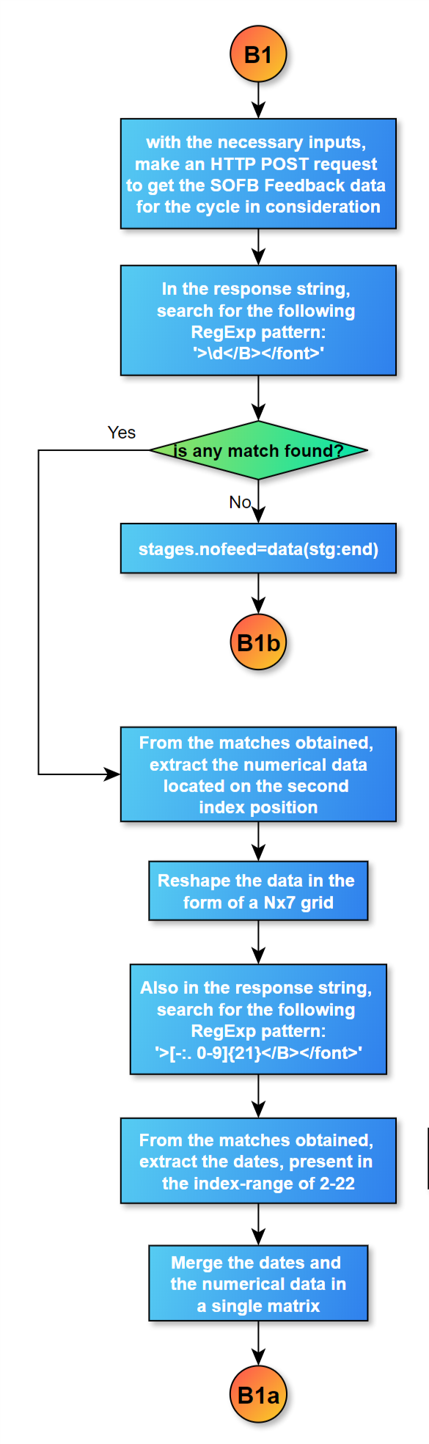

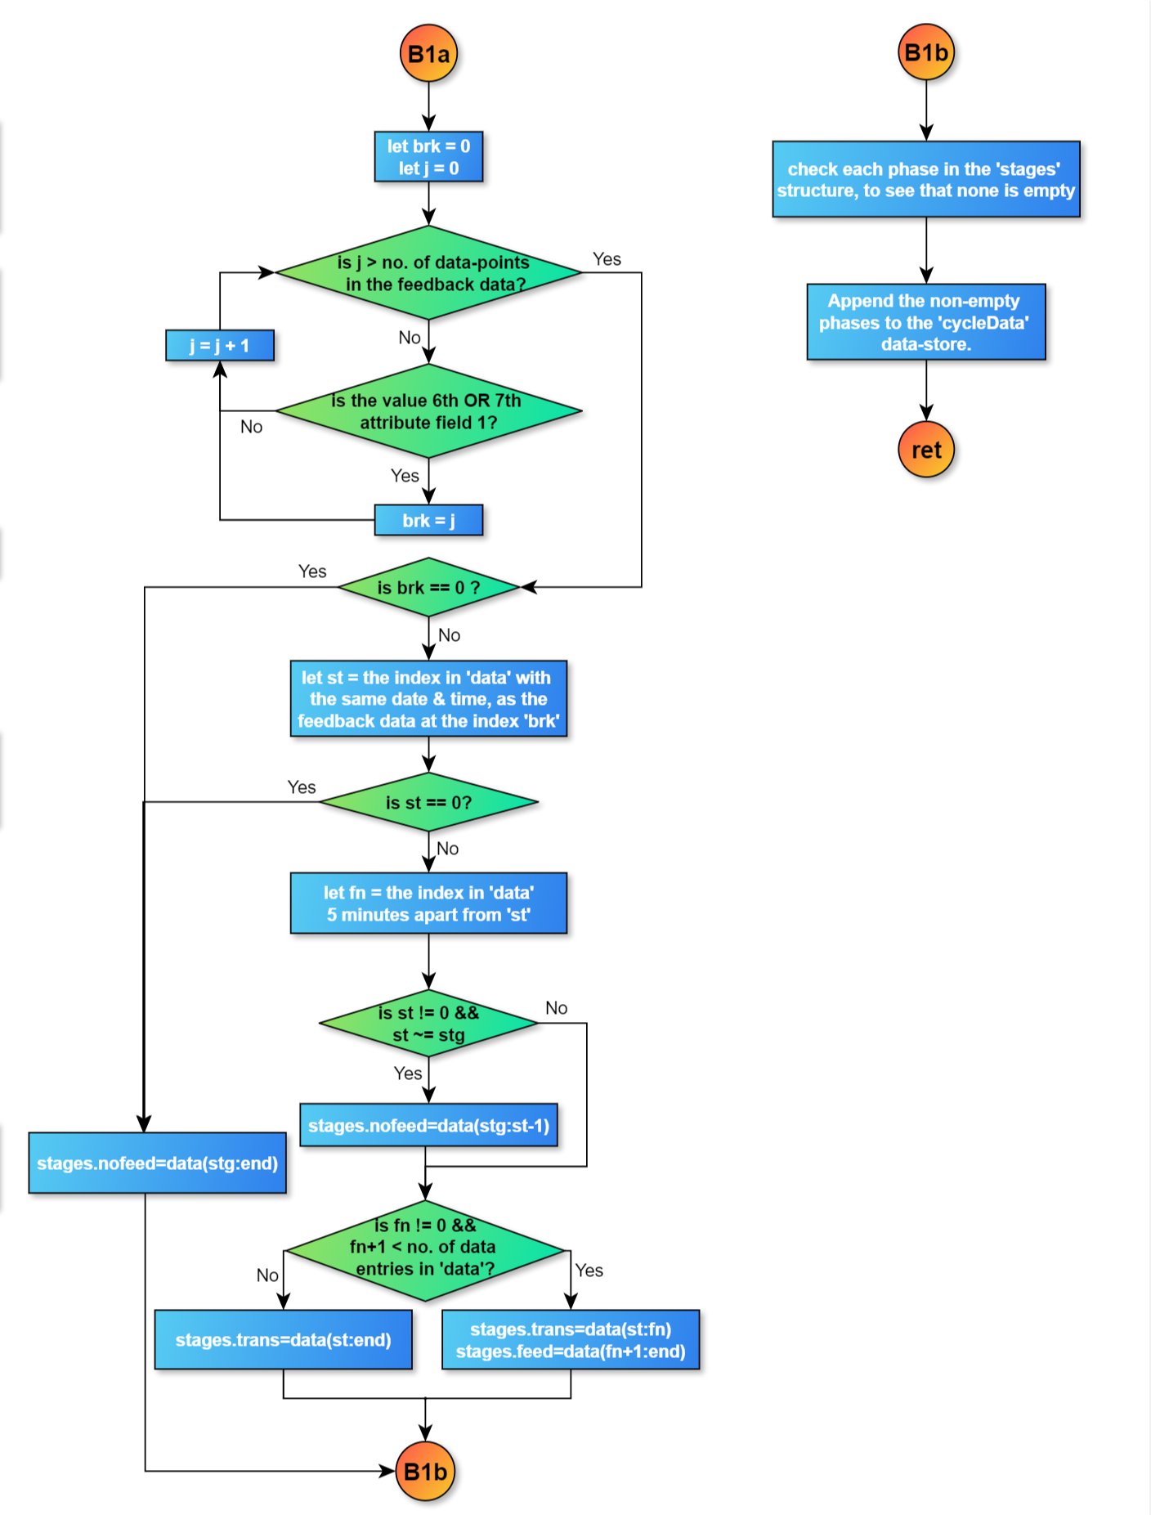

**3.2 Operational-cycles Identification Algorithm:**

Obtain the beam-info for the specified no. of days, starting from the specified date, with the required sampling-rate, from the SRS2 data-servers, via the following URL:

<http://srs2.cat.ernet.in:8100/servlet/Indus2BeamInfoDataDownloadHA>

Once the info for all the days in consideration is obtained, we check the values in the ‘Beam-Energy’ field, and look for the following patterns:

* If the value at the current and the next entry is 0, we move-on to the next entry.
* If the value at the current entry is 0, but it is non-zero at the next entry, we mark the next entry as the starting point of a new operational cycle.
* If the value at the current, as well as the next entry is non-zero, we proceed to the next entry.
* If the value at the current entry is non-zero, but the next entry is 0, we mark the current entry as the end of the cycle, identified previously.

The operational cycles thus identified by the previous algorithm present a crude partitioning of the time-scale, based upon their starting and ending-points. But these cycles need to be further passed through a filtering process, to insure that the points identified actually demarcate valid and significant cycles. Thus we remove all those data-entries from the consideration for further processing, which satisfy one or more of the following criteria:

* The value of beam-energy is less than 1mA.
* The cycle lasts for less than an hour.
* There are less than 20 entries in the cycle.

The cycles that fall in none of the above criteria are considered significant, and valid for usage. Now, the program passes-on the validated data to the function, that fetches and segments the BPI-data for the corresponding time-scale.

**3.3 Algorithm for cycle-wise segmentation of BPI-data:**

Once the program receives the indices for the starting & ending-points of the valid operational cycles, we obtain the date & time for the starting point of each cycle, along with its duration, calculated by the following logic:

**Duration = 24** x **(End date – Start date) + Hours(First Time entry) + 1**

The first part of the expression signifies the no. of days over which the cycle spans. The second part accounts for the shift in hours of the cycle from 12:00 AM on the start date. The ‘1’ at the end is added to account for the shift of the cycle, in minutes & seconds. These effects are rounded to the nearest hour-value on the higher side, so that the data for the complete cycle is guaranteed to be obtained, if present.

Based on the values of first date & time entry, calculated duration, and the required sampling-rate, the BPI-data is downloaded for the cycle in consideration, via the following API-endpoint:

<http://srs2.cat.ernet.in:8100/servlet/Indus2BPIDataDownloadHA>

Once the data is acquired, we check the time-stamps, to search the start & end-points of the cycle. The rest of the data is discarded, and this data is considered for the rest of the algorithm, for further segmentation.

Now, the BPI-data is scanned to check the existence of data-points that satisfy any of the following criterion. If they do, they are specially identified as the delimiters for the injection, ramping and storage phases:

* If until now, no such point has been identified, that its energy value is less than or equal to 550, then this point is set as the delimiter for injection phase.
* If until now, no such point has been identified, that its energy value is greater than 550, and the gradient in the energy is greater than 0.5, then this point is set as the delimiter for ramping phase.
* If until now, no such point has been identified, that its energy value is greater than 2490, and the gradient in the energy is less than 0.5, then this point is set as the delimiter for storage phase.

If all the three delimiters are identified in the given cycle, and this cycle lasts for more than an hour, then we consider this as a complete cycle, and the variable storing the no. of such cycles is incremented by 1.

* If the injection delimiter ‘*inj*’ is identified, the program checks:
  + If the ramping identifier ‘*rmp*’ is identified, and its value is greater than 1, then we assume that the injection-zone is in between ‘*inj’* and ‘*rmp-1*’.
  + Else, we assume that the injection-zone starts at ‘*inj*’ and spans across the entire cycle.
* If the ramping identifier ‘*rmp*’ is identified, the program checks:
  + If the storage identifier ‘*stg*’ is identified, and its value is greater than 1, then we assume that the ramping-zone is in between ‘*rmp’* and ‘*stg-1*’.
  + Else, we assume that the ramping-zone starts at ‘*rmp*’ and spans across the rest of the cycle.
* If the storage identifier ‘*stg*’ is identified, the program checks:
* If the mode of data-acquisition is ‘Online’. If so, it downloads the SOFB data for the given cycle, via the following URL:

<http://srs2.cat.ernet.in:8100/servlet/I2TuneSOFBHistoryHA>

* From the received document, it identifies the regex pattern: '>\d</B></font>'.
* If no matches are found, the program assumes that the entire storage region belongs to the ‘no-feedback’ zone.
* Else, it isolates the characters located on the second index, to obtain the numerical data.
* Similarly, it also identifies the regex pattern: '>[-:. 0-9]{21}</B></font>'.
* It isolates the characters present on indices 2 to 13, to obtain the time-stamps.
* It merges the dates and the numerical-data to obtain the tabular representation of the data.
* In this table, it checks if for any row, the value of the 6th or 7th column is 1. If not, it assumes that the entire storage region belongs to the ‘no-feedback’ zone.
* Otherwise, from this point, the values after 5 minutes belong to the ‘transition’ zone, and the values after that exist in the ‘with-feedback’ zone.

Once all the cycles are passed through this scrutiny, it checks the entries of all the zones, to ensure that no region that is assigned a value, is empty. Then, it returns the cycle-wise segmented BPI-data, and gives the control back to the calling method.

**3.3 Clustering Analysis Algorithm:**

Once the cycle-wise segmented BPI-data is generated, we can proceed to perform the clustering analysis on the data of the cycle, which have been previously been identified to be complete by the following criteria:

* Last for longer than 1 hour.
* Have all stages, i.e. injection, ramping, storage (without-feedback, transitioning, and with-feedback).
* Have all entries with current value greater than 1mA.

Repeat the following steps for each cycle thus considered:

* We initialize the centroids with a 1x112 zero-matrix, as well as the centroid-store ‘O’ to store the previous values of the centroids. Set the significance level to 0.01. Initialize a variable ‘Rep’, to indicate how many iterations have been completed, and whether we need to proceed with another iteration.
* Repeat the following steps, until the value of ‘Rep’ is either greater than 5, or is made 0:
  + Calculate the mean of all X & Z co-ordinates of the BPI-data of the considered cycle’s 3 phases, namely injection, storage (withou-feedback), and storage (with feedback), to obtain a 3x112 matrix of means, with 112 means in-total for each phase. These represent the co-ordinates of the three centroids of this cycle.
  + For each row in the complete data-set of the considered cycle, Find the Eucledian distance from the three centroids. Identify the centroid that gives the minimum distance, and hence is the closest. Assign the selected row to the cluster of this nearest centroid.
  + Compute the Eucledian distance between the corresponding new and the old centroid co-ordinates. If all these distances are less than the significance level, terminate the loop.
  + Else, increment the value of ‘Rep’ with 1, and assign the computed centroids to the store of old centroids ‘O’.

Chapter 4

Result

**4.1 GUI-behaviour:**

When the GUI is initially invoked, it should look like the figure below:

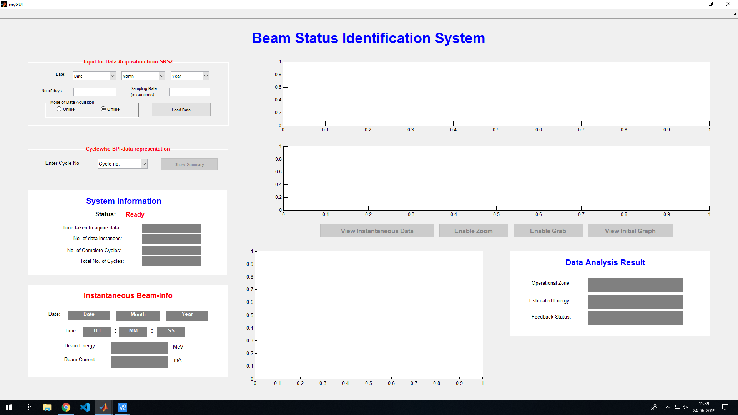

*Figure - Initial State of GUI*

The majority of the input sections and functionalities are initially disabled. The only panel active is the one, that is designed to interface with the following URL link, to obtain the Beam-Data:

<http://srs2.cat.ernet.in:8100/servlet/Indus2BeamInfoDataDownloadHA>

The panel provides the options to specify the date in the “DD-MMM-YYYY” format. Upon selection of an invalid date, such as “29-FEB-2019” or a date that is yet to pass, like “20-JUN-2050”, an invalid-input error message is generated instantly, prompting the user to provide the correct input. Also, the user is required to specify the no. of days for which the analysis to be performed, and the data is to be acquired. The sampling-rate of the data is also a required field, and upon specifying an invalid value for either of these, like a character/special symbol, an error message is generated to inform the user of the invalid input. Another option asks the user to specify the mode of data acquisition, i.e. whether the data should be read from the the SRS2 data-servers via the above link, or from local data-library. The default value for this field in set as ‘Offline’.

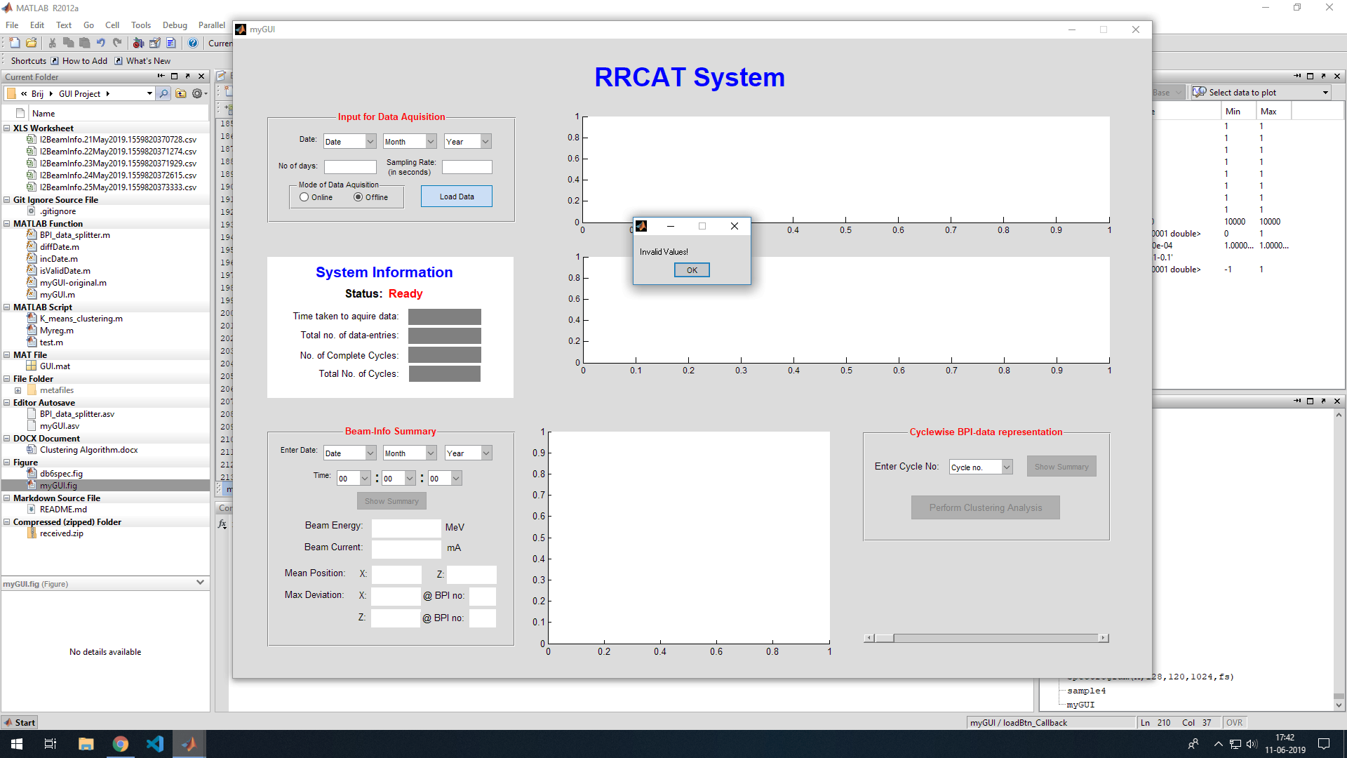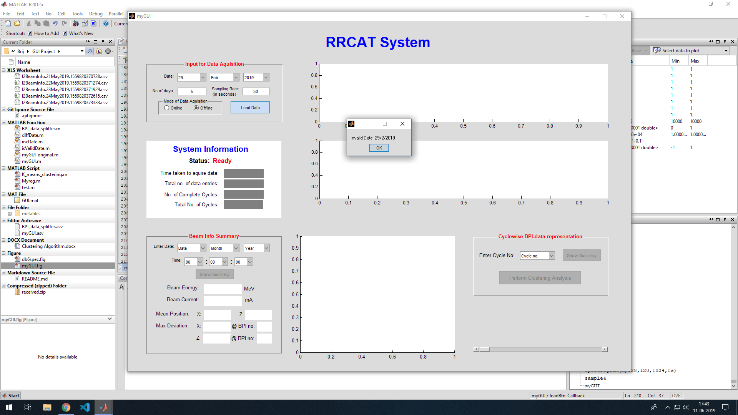

It should be noted that if the data is fetched from the online source, the existing data will be over-written. Thus, if the data needs to be stored for future reference, it must be saved separately. In order to load the data from the offline source, the following directory structure is mandatory:

*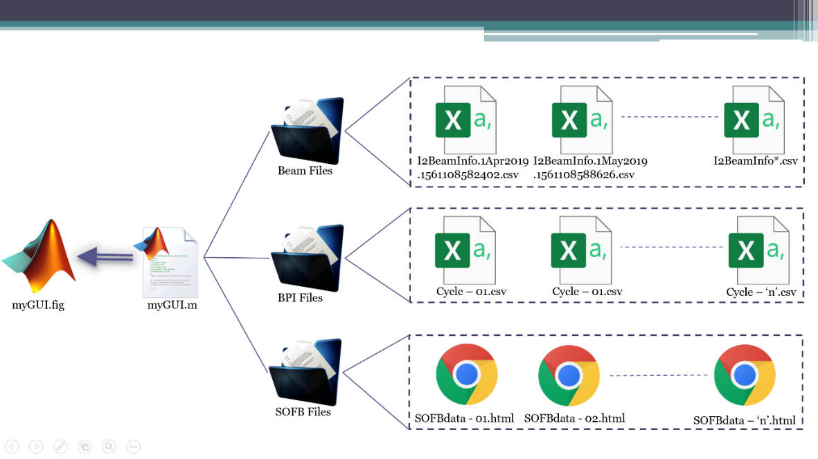Figure - Directory structure of the project*

*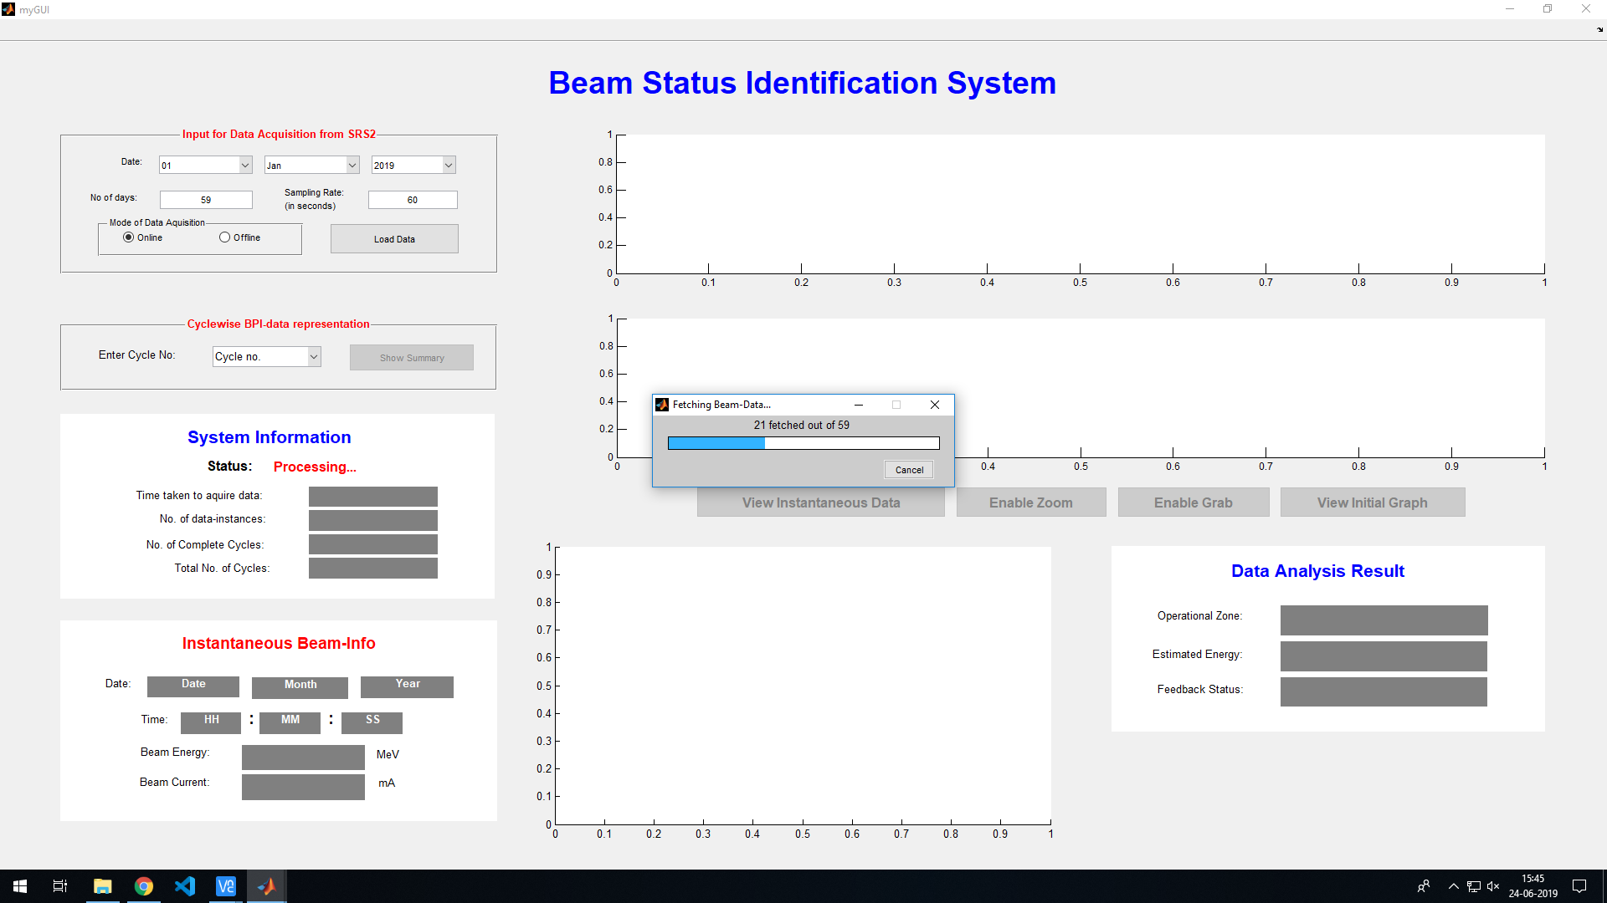*Upon receiving acceptable values for all the specified fields, the program proceeds to make repeated HTTP POST requests to the previously specified URL, if the specified mode is “Online”, based on the no. of days specified by the user. For each iteration, the request is made, the received zip file is saved, extracted, and the extracted file is moved to the ‘Beam Files’ directory.

*Figure - Status-bar for Beam-info*

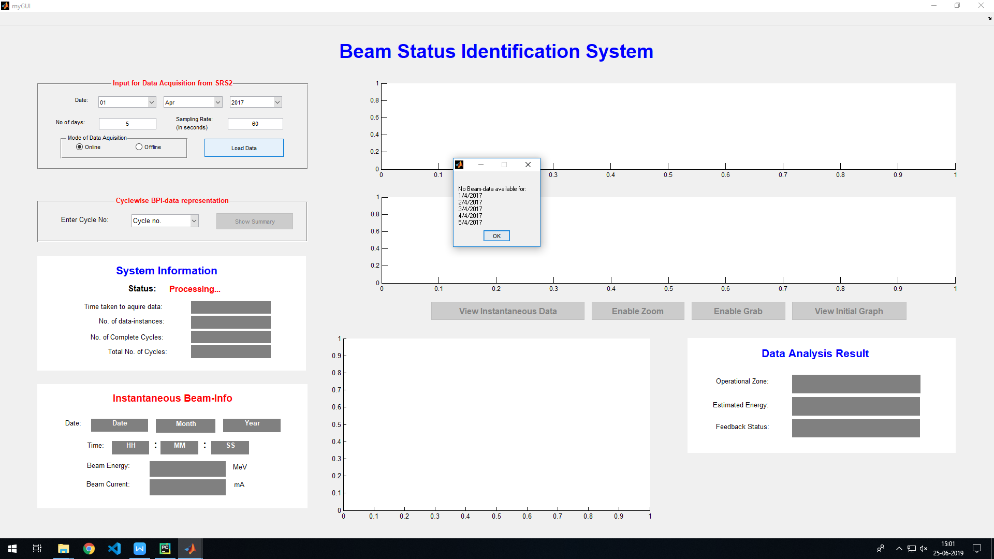For each iteration, a progress-bar is updated to inform the user of the progress of the data-fetching mechanism. Also, it may happen that the server does not possess the data for the day in question. In such cases, the date is appended to a special store, and are displayed together at the end of the data-fetching procedure, without causing any interruption in its running.

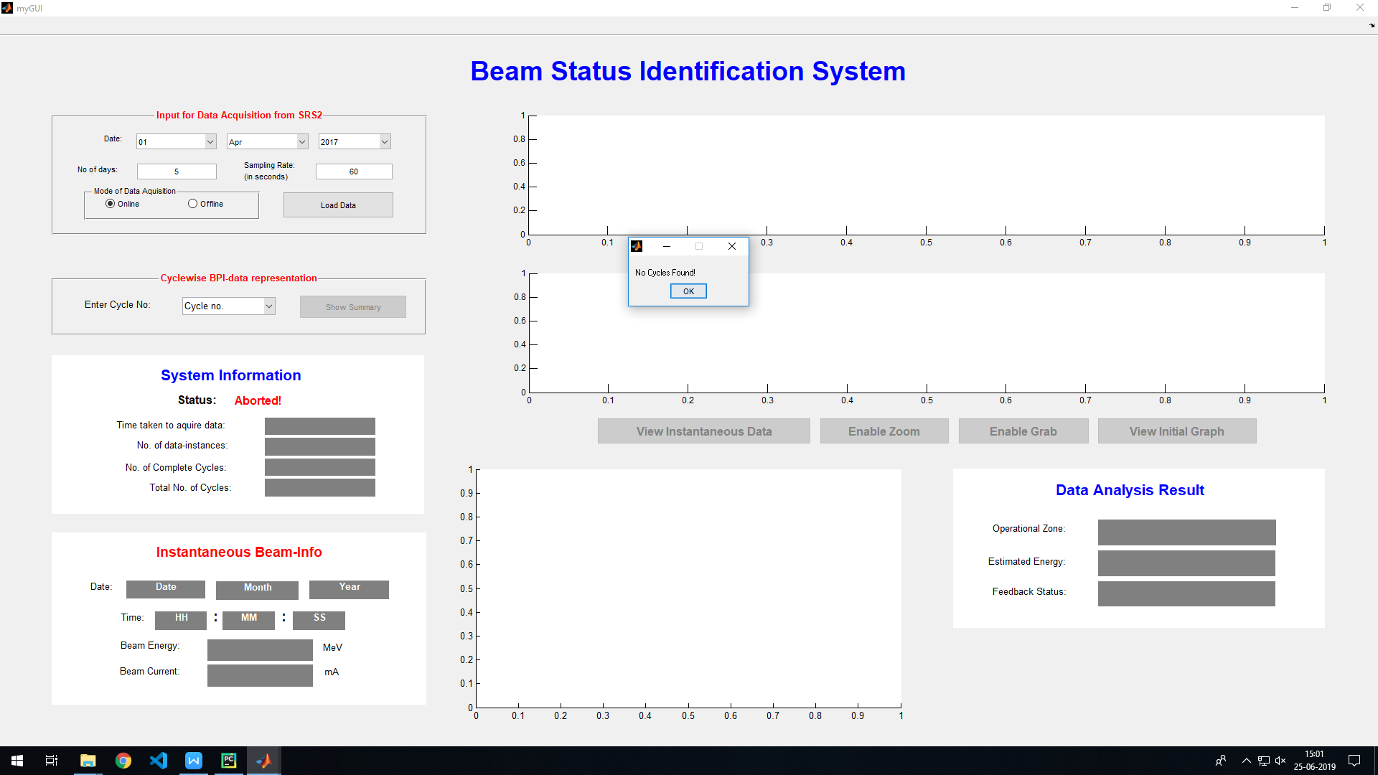The program runs the Cycle-identification algorithm, and if no cycles are found, an error is generated. Else, the program passes on the information about the indices of the valid operational cycles to the function that acquires and splits the BPI-data accordingly. This function returns the cycle-wise segmented BPI-data, which is then further used for the clustering analysis.

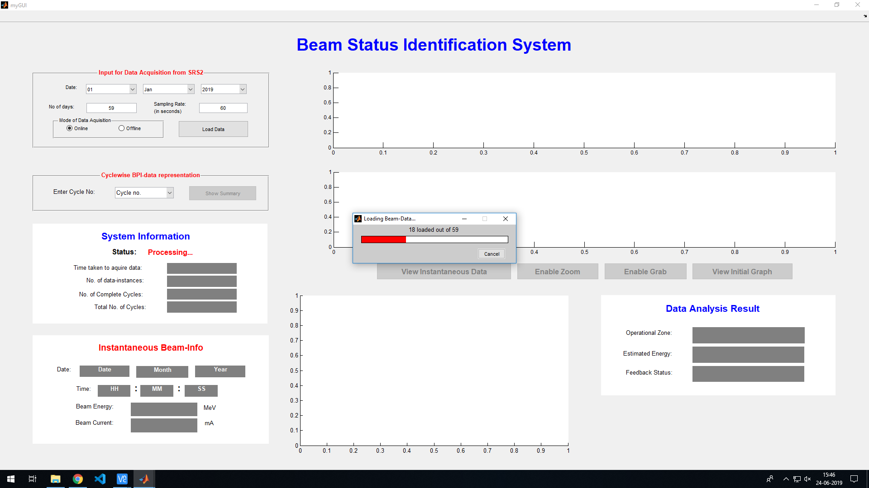

*Figure - Beam-data Processing for Cycle identification*

Once the clustering completes, the beam-data, the complete BPI-data, the segmented BPI-data, and the clustered BPI-data are appended to the global handle of the GUI, to enable other methods to use them. After that, the Beam energy and current graphs for the entire specified duration are plotted, to broadly describe the beam-profile, and also to act as the means of input for the Identification-analysis, via the ‘kNN’ algorithm.

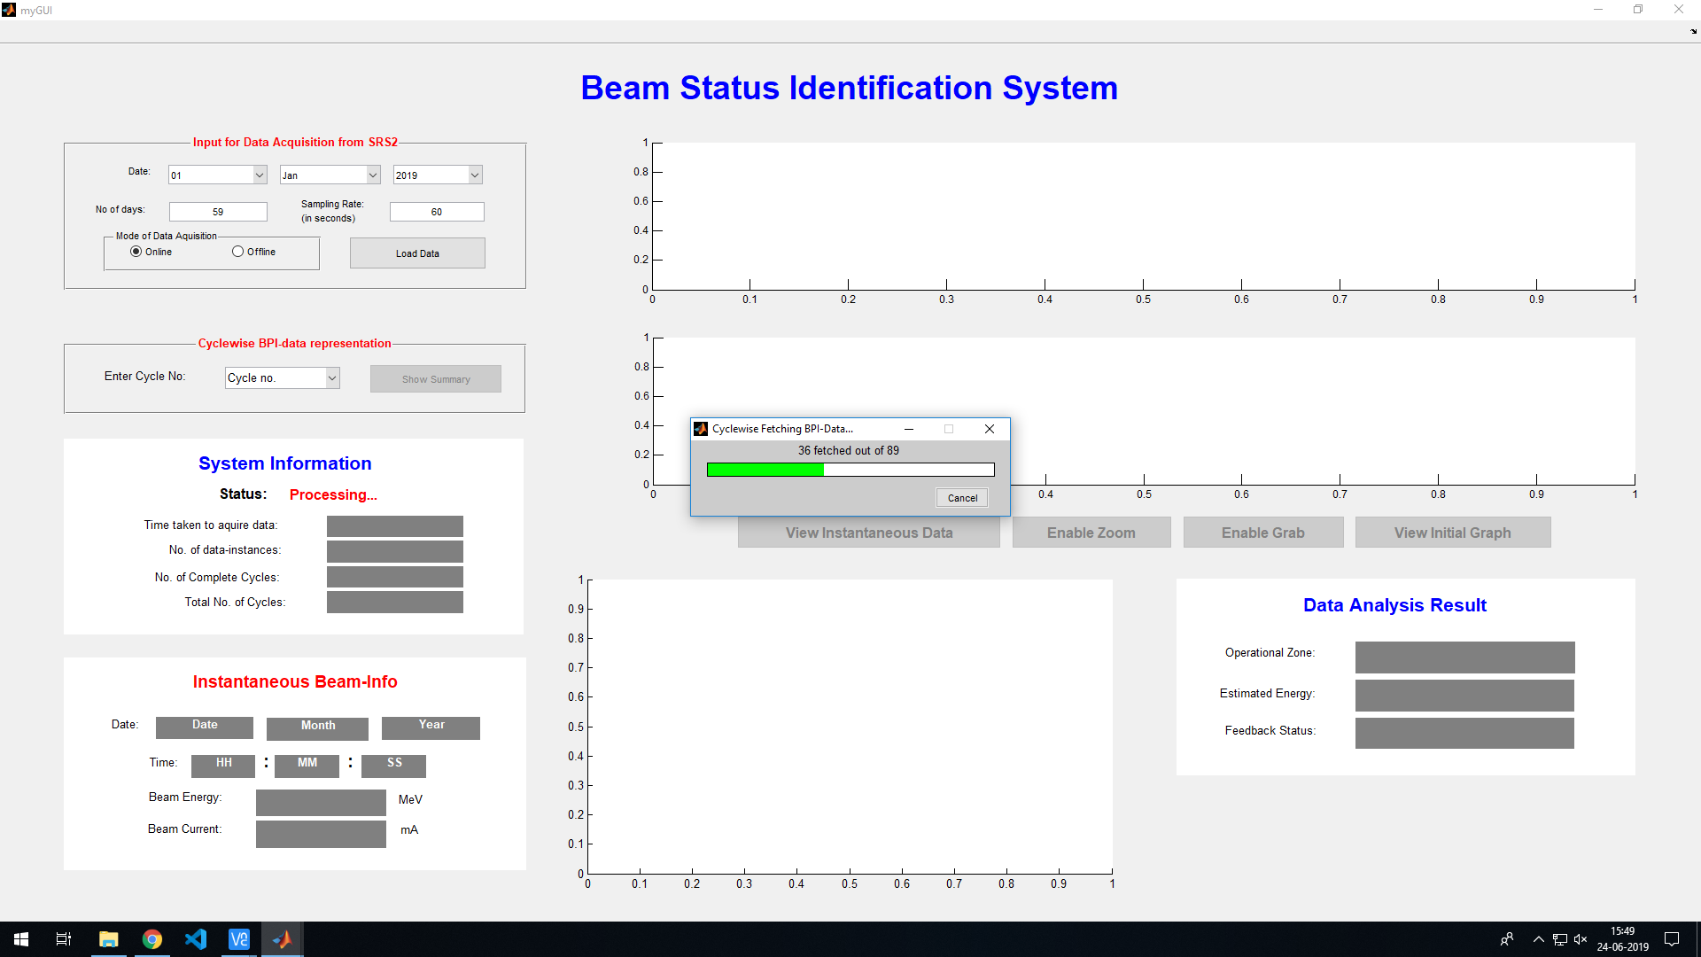

*Figure - fetching and segmentation of BPI-data*

*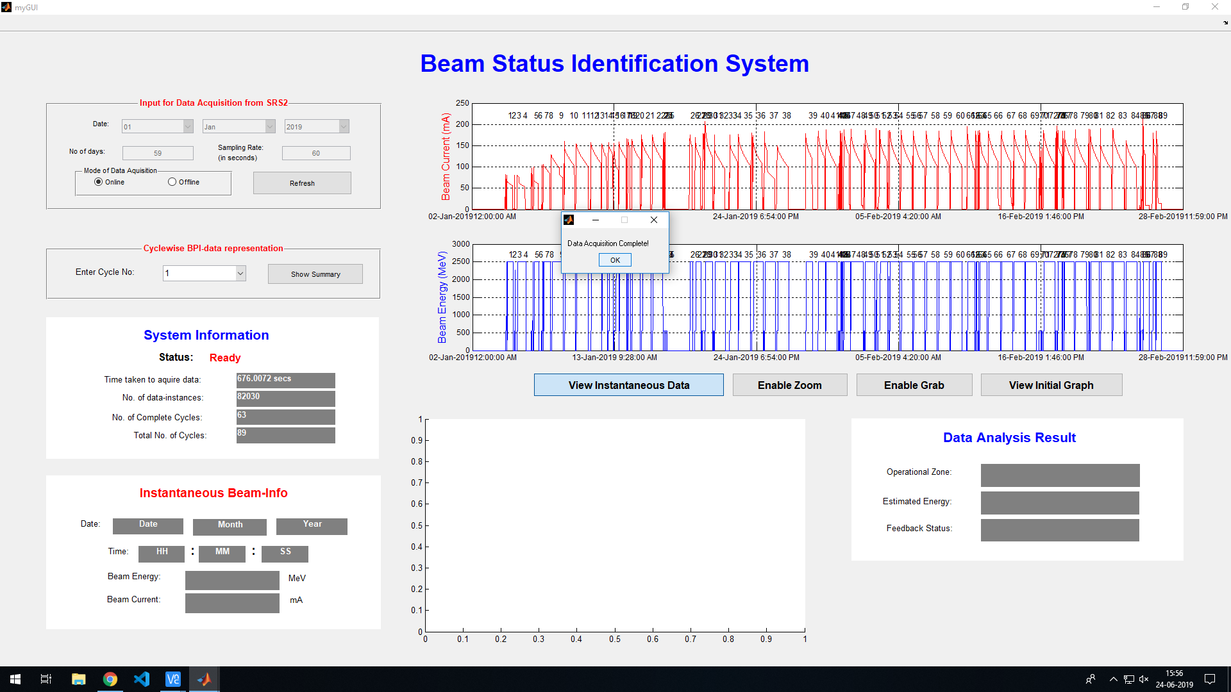*

*Figure – completion of the initial setup phase of the GUI*

The GUI also provides an option to view the detailed graph for each cycle, along with the related BPI-data, segmented according to the previously-mentioned conditions.

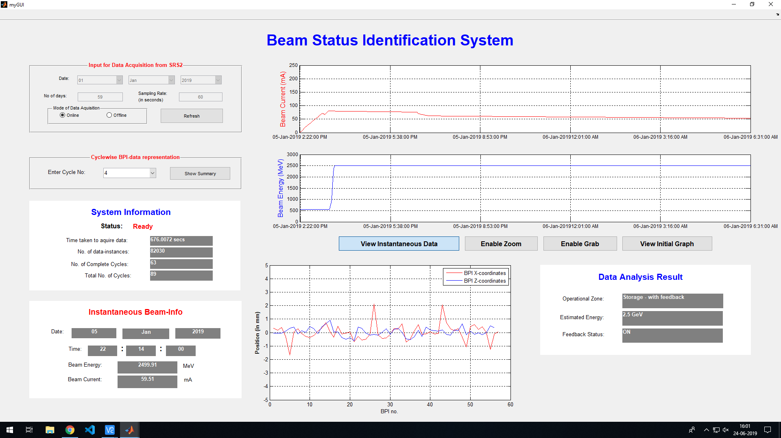

*Figure – Expanded view of the Beam Energy and Current plots for the cycle*

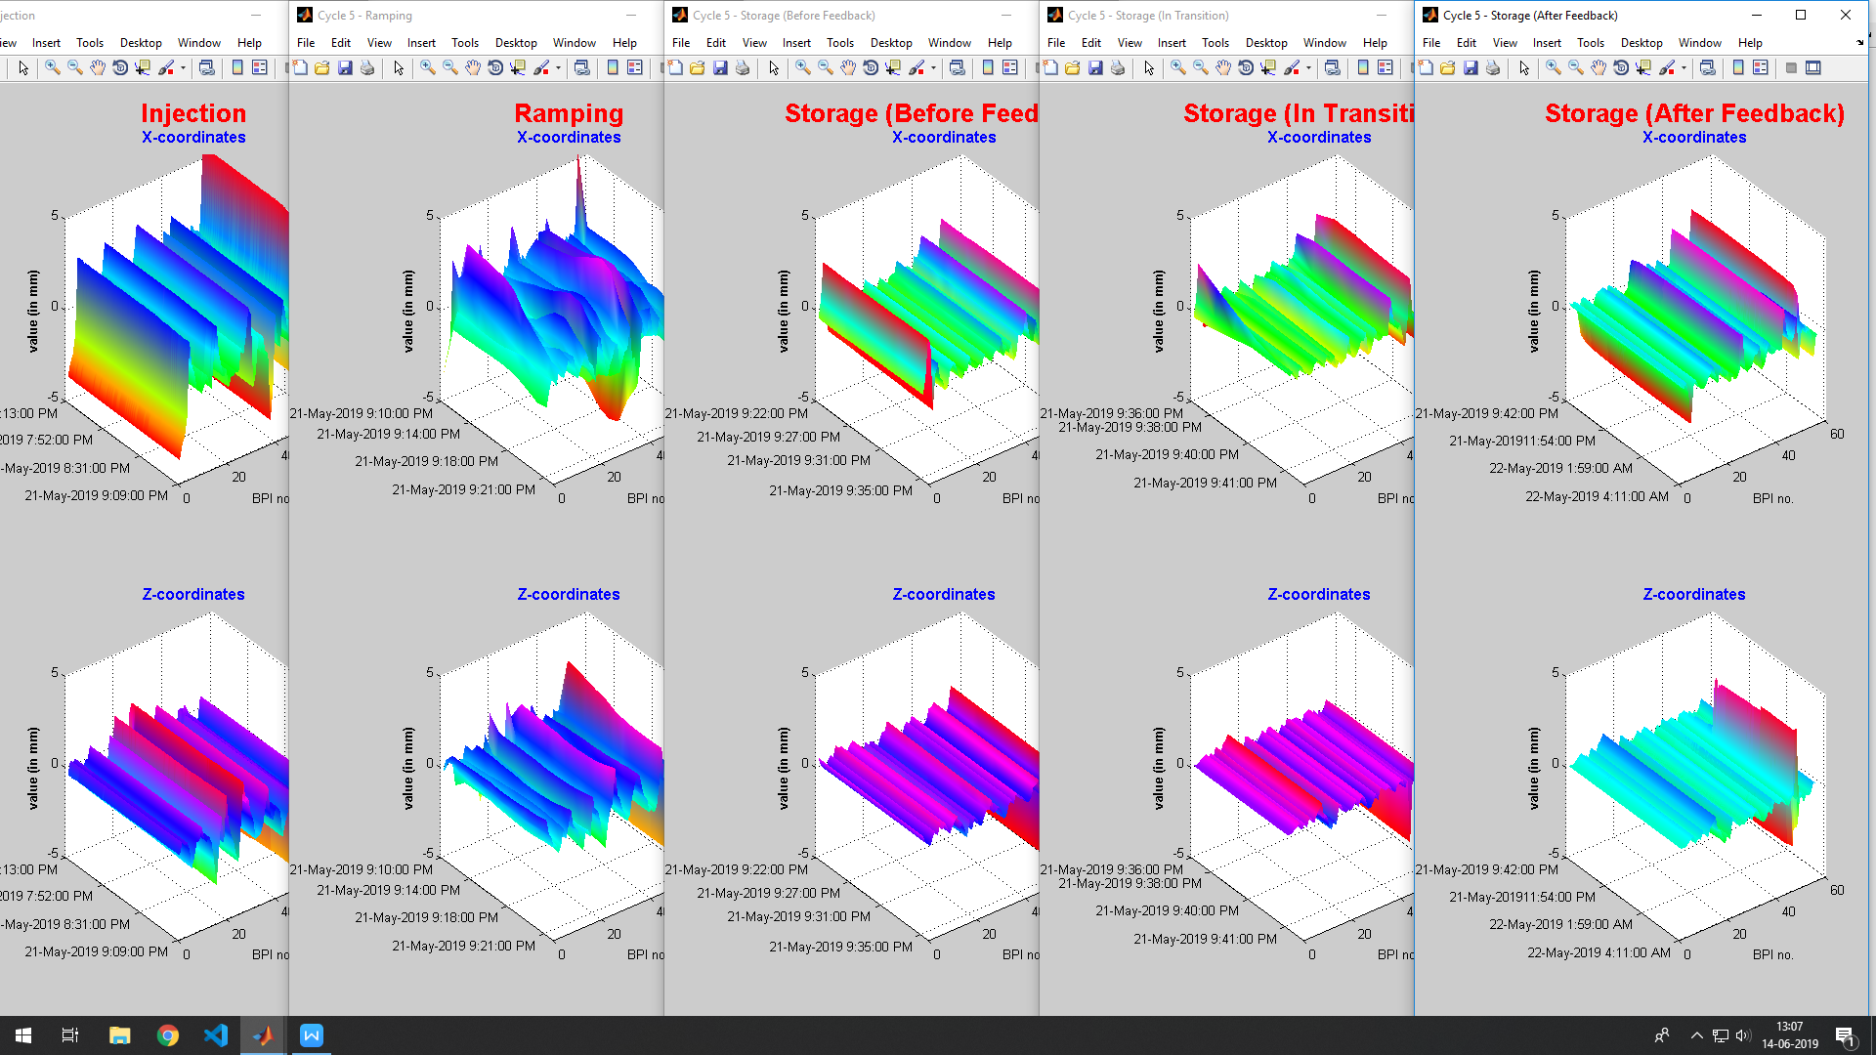

*Figure – detailed view of the segmented BPI-data for the cycle*

The x-axis of the BPI-graphs represent the BPI-no, between 1 and 56. The Y-axis represents the value of the BPI co-ordinate, at the considered instance of time. The Z-axis represents the variation of the value of the BPI-data, over the time-span of the segment of the cycle. These graphs help in understanding the behaviour, and the deviations produced in the beam.

**4.2 Clustering Analysis:**

The received cycle-wise segmented BPI-data that we are dealing with in this project, is numerical in nature, varies in a case-wise similar range, and is significantly distinguishable. Thus, we can say that the use of K-means clustering algorithm is justified here.

When the k-means clustering algorithm was applied to the received BPI-data, the Eucledian distances obtained from the corresponding centroids for the considered cycles was found to be as follows:

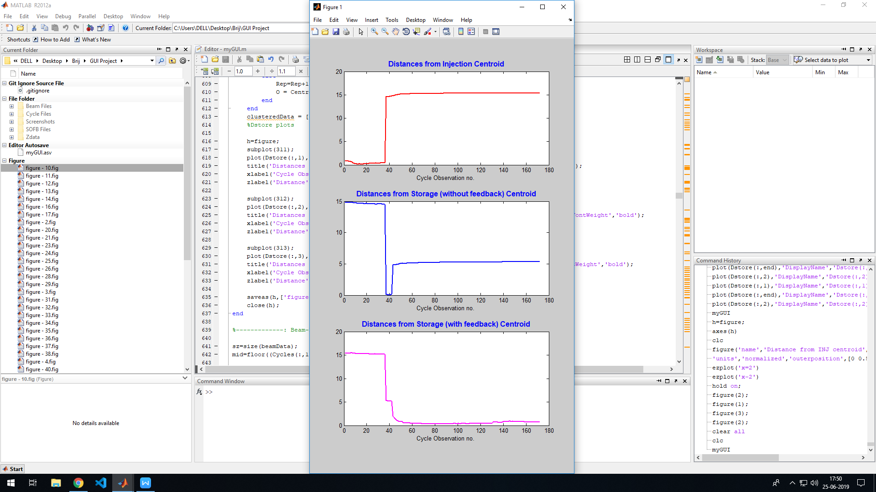

*Figure - Distances from various centroids*

As we can see, the observations for the Euclidean distances quite discretely identify the three phases of the beam, considered for the clustering analysis. The observations near the start of these graphs belong to the Injection phase. As seen in the figure, the centroid from which the distance of these observations is minimum, is that of the Injection phase (topmost-plot).

Similarly, the data-points that belong to the ‘without-feedback’ phase of the cycle have the minimum distance from the centroid of the corresponding class (middle-plot), and the same is true for the ‘with-feedback’ phase (bottom-plot).

Thus, in this case, the k-means clustering can be considered to be a valid classifier, that can be used to classify similar data, into classes with similar properties. These classes can then be used for the process of identification, which will take these classes as an input.

**4.3 Beam-Status Identification:**

Once the training data-set (the BPI-data of the three phases discussed above) is successfully classified, it is passed on to the k-Nearest Neighbour (kNN) algorithm, which also gets the input BPI-data from the user via the plots of Beam-Energy and Beam-Current, and based upon the classes of the obtained nearest neighbors, we predict the values of the following parameters of the Indus-2 beam:

* Beam Energy
* Phase of the operational cycle
* SOFB feedback status

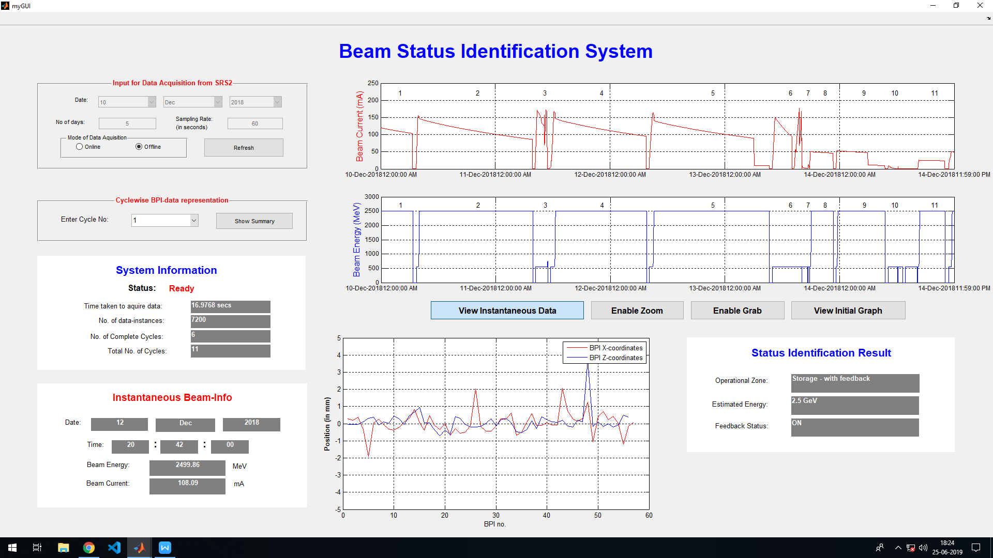

Conclusion

The work done in this project was mainly focused on the design and development of the beam status identification system. For that, a familiarization with the usage and development in MATLAB was achieved. Special importance was given to the study of the method of developing Graphical User Interfaces (GUIs) in MATLAB, using the GUIDE tool.

The development of this project enhanced the familiarity with the Indus Accelerator Complex, and the operation of the Indus-2 synchrotron radiation source. Special analysis and focus were placed on the understanding of the BPI-data values, and its retrieval techniques. This helped in construction of the interfacing techniques used for obtaining data from the SRS2 data-servers, as well as for segmenting the data, into various segments for each operational cycle. This also required learning about the need and working of the Slow-Orbit Feedback (SOFB) system, whose data was also used to judge which data was fit for consideration as a training data-set for the further analysis.

The project also made use of core data-mining techniques, thus providing exposure to the process-flow followed in the field of data-science. Special focus was on the process of K-means clustering algorithm, that helped in classification of the cycle-wise segmented BPI-data, for further analysis.

Finally, the k-Nearest Neighbours algorithm was also applied to predict the value of the following beam-parameters, based upon the input BPI-data:

* Beam Energy
* Zone of operation
* SOFB Feedback status

It was a pleasant experience to work on this project, and to achieve the goals that were decided-upon.

References

1. An Efficient k-means Clustering Algorithm: Analysis and Implementation by Tapas Kanungo, David M. Mount, Nathan S. Netanyahu, Christine D. Piatko, Ruth Silverman and Angela Y. Wu.
2. Research issues on K-means Algorithm: An Experimental Trial Using Matlab by Joaquin Perez Ortega, Ma. Del, Rocio Boone Rojas and Maria J. Somodevilla Garcia.
3. The k-means algorithm - Notes by Tan, Steinbach, Kumar Ghosh.
4. <http://home.dei.polimi.it/matteucc/Clustering/tutorial_html/kmeans.html>
5. <https://sites.google.com/site/dataclusteringalgorithms/k-means-clustering-algorithm>
6. P.K. Agarwal and C.M. Procopiuc, ªExact and Approximation Algorithms for Clustering,º Proc. Ninth Ann. ACM-SIAM Symp. Discrete Algorithms, pp. 658-667, Jan. 1998.
7. K. Alsabti, S. Ranka, and V. Singh, ªAn Efficient k-means Clustering Algorithm,º Proc. First Workshop High Performance Data Mining, Mar. 1998.
8. S. Arora, P. Raghavan, and S. Rao, ªApproximation Schemes for Euclidean k-median and Related Problems,º Proc. 30th Ann. ACM Symp. Theory of Computing, pp. 106-113, May 1998.
9. S. Arya and D. M. Mount, ªApproximate Range Searching,º Computational Geometry: Theory and Applications, vol. 17, pp. 135-163, 2000.
10. S. Arya, D.M. Mount, N.S. Netanyahu, R. Silverman, and A.Y. Wu, ªAn Optimal Algorithm for Approximate Nearest Neighbor Searching,º J. ACM, vol. 45, pp. 891-923, 1998.
11. G.H. Ball and D.J. Hall, ªSome Fundamental Concepts and Synthesis Procedures for Pattern Recognition Preprocessors,º Proc. Int'l Conf. Microwaves, Circuit Theory, and Information Theory, Sept. 1964.
12. <https://www.datascience.com/blog/k-means-clustering>
13. Bailey, T. & Jain, A. (1978) "A note on distance-weighted k-Nearest Neighbor rules", IEEE Trans. Systems, Man, Cybernetics, 8: 311-313.
14. [3] Baoli, L., Shiwen, Y. & Qin, L. (2003) "An Improved k-Nearest Neighbor Algorithm for Text Categorization, ArXiv Computer Science e-prints.
15. Assi, Ali & Al Shamisi, Maitha & Hejase, Hassan. (2011). MATLAB GUI Application for Teaching Electronics. 10.5772/25202.
16. Nasiruzzaman, ABM. (2010). Using MATLAB to Develop Standalone Graphical User Interface (GUI) Software Packages for Educational Purposes.

Appendix